

**Examination**

##### Question/Answer Booklet

Please place your student identification label in this box

CHEMISTRY

**STAGE 3AB**

**Semester 1 examination**

### Time allowed for this paper

Reading time before commencing work: Ten minutes

Working time for paper: Three hours

### Material required/recommended for this paper

# To be provided by the supervisor

Question/answer booklet

Separate multiple-choice answer sheet

Data sheet

# To be provided by the candidate

Standard items: Pens, pencils, eraser, correction fluid, ruler, highlighter

Special items: Scientific calculator

# *Important note to candidates*

No other items may be taken into the examination room. It is **your** responsibility to ensure that you do not have any unauthorised notes or other items of a non-personal nature in the examination room. If you have any unauthorised material with you, hand it to the supervisor **before** reading any further.

|  |  |  |
| --- | --- | --- |
| **Section** | **Out Of** |  |
| Multiple Choice | /50 |
| Short Answers | /68 |
| Extended response | /73 |
| **Total** | /191 | **%** |

***Structure of this paper***

|  |  |  |  |  |  |
| --- | --- | --- | --- | --- | --- |
| Section | Suggested working time | Number of questions available | Number of questions to be attempted | %  of paper | Marks |
| ONE  Multiple choice | 50 minutes | 25 | 25 | 26 | 50 |
| TWO  Short response | 60 minutes | 12 | 12 | 36 | 69 |
| THREE  Extended response | 70 minutes | 6 | 6 | 38 | 72 |
|  |  |  | Total | 100 | 191 |

***Instructions to candidates***

1. The rules for the conduct of Curriculum Council examinations are detailed in the *Student Information Handbook*. Sitting this examination implies that you agree to abide by these rules.

2. Answer the questions according to the following instructions.

**Section One** Answer all questions in the separate multiple-choice answer sheet provided.

**Section Two** Answer **all** questions in the spaces provided in this Question/Answer Booklet.

**Section Three** Answer **all** questions in the spaces provided in this Question/Answer Booklet

3. A blue or black ballpoint or ink pen should be used.

4. For full marks, chemical equations should refer only to those species consumed in the reaction and the new species produced. These species may be **ions** [for example (*aq*)], **molecules** [for example NH3(*g*),NH3(*aq*),CH3COOH*()*, CH3COOH*(aq)*] or **solids** [for example BaSO4*(s)* ,Cu*(s)*, Na2SO4(*s*)].

5. Additional information which may be necessary to answer questions is located on the separate Chemistry data sheet.

**SECTION ONE—MULTIPLE-CHOICE [50 marks]**

This section has **TWENTYFIVE (25)** questions. Attempt **ALL** questions.

Answer allquestions in Section 1 on the separate Multiple-Choice Answer Sheet provided, using a blue or black pen. Each question in this part is worth 2 marks.

Suggested working time: 50 minutes.

_______________________________________________________________________

1. A student performed a sampling technique as part of a first-hand investigation on water quality and repeated the sampling technique several times.

What aspect of the experiment was improved by repeating the procedure?

a) accuracy

b) reliability

c) safety

d) validity

2. Acid X is 0.1 mol L-1 hydrochloric acid.

Acid Y is 1.0 mol L-1 acetic acid (ethanoic acid)

How does acid X compare with acid Y?

a) X is weaker and more dilute than Y

b) X is stronger and more dilute than Y

c) X is weaker and more concentrated than Y

d) X is stronger and more concentrated than Y

3. Which statement best described the equivalence point in a titration between a strong acid and a strong base?

a) The point at which the first sign of a colour change occurs

b) The point at which equal moles of acid and base have been added together

c) The point at which equal moles of H+ ions and OH- ions have been added together.

d) The point at which the rate of the forward reaction equals the rate of the reverse reaction.

4. Which of the following aqueous solutions has a pH greater than 7?

a) Sodium acetate

b) Sodium chloride

c) Ammonium nitrate

d) Ammonium chloride

5. What are the volumes of one mole of argon, Ar, and one mole of fluorine, F2, at 0°C and 100 kPa?

|  |  |  |
| --- | --- | --- |
|  | *Volume* (litres) | |
|  | Ar | F2 |
| a) | 12.40 | 24.79 |
| b) | 22.70 | 22.70 |
| c) | 22.70 | 45.42 |
| d) | 24.79 | 24.79 |

6. A 330mL can of an energy drink has a sucrose concentration of 0.120 molL-1. If it is diluted with water until the total volume is 1.00L, what is the new sucrose concentration?

1. 0.000364 molL-1
2. 0.364 molL-1
3. 0.0396 molL-1
4. 3.64 molL-1

7. Which one of the following salts **cannot** be prepared by reacting a metal with a dilute acid?

a) copper II chloride

b) iron II chloride

c) magnesium sulfate

d) zinc sulfate

8. A sample of water is being heated from 20°C to 30°C, and the temperature is recorded every 2 minutes. Which table would be most appropriate for recording the data?

a) b) c) d)

|  |  |  |  |  |  |  |  |  |  |  |
| --- | --- | --- | --- | --- | --- | --- | --- | --- | --- | --- |
| **Time (min)** | **Temp**  **(°C)** |  | **Time (min)** | **Temp**  **(°C)** |  | **Temp**  **(°C)** | **Time (min)** |  | **Temp**  **(°C)** | **Time (min)** |
| 0 |  |  | 20 |  |  | 0 |  |  | 20 |  |
| 2 |  |  | 22 |  |  | 2 |  |  | 22 |  |
| 4 |  |  | 24 |  |  | 4 |  |  | 24 |  |
| 6 |  |  | 26 |  |  | 6 |  |  | 26 |  |
| 8 |  |  | 28 |  |  | 8 |  |  | 28 |  |
| 10 |  |  | 30 |  |  | 10 |  |  | 30 |  |

9. The diagram below represents a Celsius thermometer recording a certain temperature.

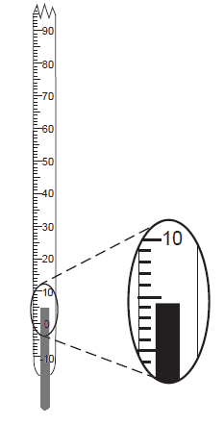

What is the correct reading of the thermometer?

a) 5°C

b) 4.3°C

c) 0.3°C

d) 4°C

10. A student dissolves a substance in water, tests the resulting solution, and observes that red litmus paper turns blue. Based on this result, the solution is

a) organic

b) inorganic

c) basic

d) acidic

11. Given the reaction:

HSO4- + HPO42- ⇌ SO42- + H2PO4-

Which pair represents an acid and its conjugate base?

a) HSO4- and SO42-

b) HSO4- and HPO42-

c) SO42- and H2PO4-

d) SO42- and HPO42-

12. Which species contains only 12 protons in the nucleus?

a)



b)



c)



d)



13. Which group contains elements that are monatomic gases at STP?

a) 1

b) 2

c) 17

d) 18

14. The Dead Sea is the saltiest sea in the world. It contains 332 grams of salt per 1000 grams of water. What is the concentration in parts per million (ppm)?

a) 0.332 ppm

b) 332 ppm

c) 33,200 ppm

d) 332,000 ppm

15. Consider the following reaction at equilibrium in a container of constant volume

2SO2(g) + O2(g) ⇌ 2SO3(g) ∆H = -33 kJ

Which of the following would result in a greater concentration of SO2?

a) addition of oxygen

b) decreasing the temperature

c) addition of sulfur trioxide

d) removal of sulfur trioxide

16. An element has the first five successive ionisation energies as shown in the graph below

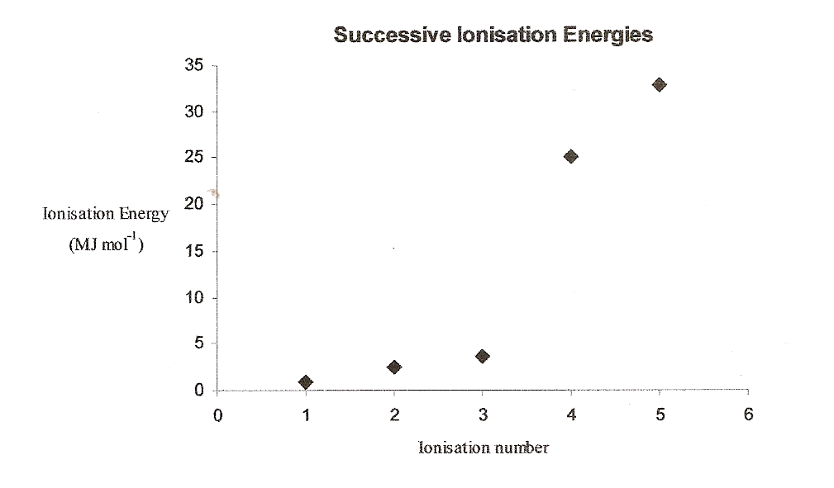

Which one of the following is it?

1. calcium
2. carbon
3. nitrogen
4. boron

17. Which of the following would NOT give a VISIBLE reaction with dilute hydrochloric acid?

1. solid Zn(OH)2
2. a solution of KOH
3. a solution of Pb(NO3)2
4. a saturated solution of Ag2SO4

18. Which of the following tests would **not** be useful in distinguishing between 1.0M solutions of hydrochloric acid (HCl) and hydrofluoric acid (HF)?

1. measuring the pH of each solution
2. measuring the conductivity of each solution
3. observing the rate at which hydrogen is evolved from a piece of magnesium
4. measuring how much sodium hydroxide is needed to neutralise each acid

19. Which of the following is commonly used as a primary standard in volumetric analysis?

1. sulfuric acid
2. potassium permanganate
3. sodium carbonate
4. sodium hydroxide

20. Which one of the following processes is exothermic?

a) Li(g) → Li+(g) + e-

b) H2(g) → 2H(g)

c) H2O(l) → H2O(s)

d) NaCl(s) → Na+(aq) + Cl-(aq)

21. In an experiment a student reacted 1.00g of each of the following carbonates with excess dilute hydrochloric acid and collected the gas at 20oC and 101kPa in each case. Which carbonate produced the greatest volume of gas?

1. Na2CO3
2. K2CO3
3. MgCO3
4. CaCO3

22. A gardener needs a fertiliser solution containing ions that will supply nitrogen, phosphorus and potassium to her vegetables. Which one of the following mixtures of solids will completely dissolve to produce the required solution?

a) KCl Ca(NO3)2 Na3PO4

b) K2CO3 K3PO4 Ba(NO3)2

c) NH4NO3 Na3PO4 Ca(NO3)2

d) KCl Na3PO4 (NH4)2SO4

23. Which one of the following can act as a Bronsted-Lowry base but **not** a Bronsted-Lowry acid?

1. HCO3-
2. H2SO4
3. HSO4-
4. SO42-

24. Which one of the statements about the activated complex produced during a chemical reaction is NOT correct?

1. It is unstable and can decompose to either the reactants or the products
2. Of all the species involved in the reaction it is the one that has the highest energy
3. Its composition for a catalysed reaction is the same as for an uncatalysed reaction
4. Its energy will be the same for the forward or reverse reaction

25. Which one of the following reactions is NOT an acid-base reaction?

a) HClO(aq) + H2O2(aq) ↔ Cl-(aq) + H2O(l) + H+(aq) + O2(g)

b) HS-(aq) + H2O(l) ↔ H2S(aq) + OH-(aq)

c) HClO(aq) + CH3COO-(aq) ↔ ClO-(aq) + CH3COOH(aq)

d) CH3COOH(aq) + CO32-(aq) ↔ CH3COO-(aq) + HCO3-(aq)

**SECTION TWO—SHORT RESPONSE [69 marks]**

Section Two contains **twelve (12)** questions. Attempt **ALL** questions in the spaces provided.

In this section, unless asked to write molecular equations, chemical equations should refer only to those species consumed in the reaction and the new species produced. These species may be **ions** [for example(*aq*), **molecules** [for example NH3(*g*),NH3(aq),CH3COOH*()*, CH3COOH*(aq)* ] or **solids** [for example BaSO4*(s)* ,Cu*(s)*, Na2SO4(s)].

Suggested working time: 60 minutes

________________________________________________________________________

**Question 1 [6 marks]**

Write equations for any reactions that occur in the following procedures. If no reaction occurs write ‘no reaction’.

In each case describe in full what you would observe, including any

* Colours
* Odours
* Precipitates (give the colour)
* Gases evolved (give the colour or describe as colourless)

If no change is observed, you should state this.

a) Dilute hydrochloric acid is added to copper metal

**Equation** ___________________________________________________________

Observation ___________________________________________________________

_______________________________________________________________________

(3 marks)

b) Solid potassium carbonate is added to dilute acetic acid.

**Equation** ___________________________________________________________

Observation ___________________________________________________________

_______________________________________________________________________

(3 marks)

**Question 2 [ 4 marks]**

Write the electronic configuration for the following species

a) an argon atom ___________________________

b) a sodium ion ___________________________

c) a magnesium atom ___________________________

d) a nitride ion ___________________________

**Question 3 [4 marks]**

1. Classify the following salts as forming acidic, basic or neutral solutions.

|  |  |
| --- | --- |
| **salt** | **classification** |
| Ammonium chloride |  |
| Potassium fluoride |  |
| Sodium chloride |  |
| Sodium carbonate |  |

(2 marks)

1. From the table choose a salt that forms an acidic or basic solution and justify its classification. Include an equation to illustrate your answer.

(2 marks)

**Question 4 [5 marks]**

1. Describe and explain the trend in atomic radii of the atoms Na, Mg, Al and Si.

(2 marks)

1. Describe the trend in the atomic radii of the atoms F, Cl and Br. Explain how this affects their ease of conversion to the ions F-, Cl- and Br -.

(3 marks)

**Question 5 [ 3 marks]**

Many foods that contain citric acid also have sodium citrate added as an ‘acidity regulator’. This means that the mixture acts as a buffer solution.

**equation 1** HA ↔ H+ + A-

Use **equation 1** to explain how a buffer solution containing HA and A- works.

___________________________________________________________________

___________________________________________________________________

___________________________________________________________________

___________________________________________________________________

___________________________________________________________________

___________________________________________________________________

**Question 6 [6 marks]**

For each species listed in the table below, draw the structural formula, representing all valence electron shell pairs as : or – and state or draw the shape of the molecule or ion.

|  |  |  |
| --- | --- | --- |
| **Molecule or ion** | **Structural formula**  **(showing all valence shell electrons)** | **Shape**  **(sketch or name)** |
| Carbon disulfide  CS2 |  |  |
| NCF |  |  |
| hydrogencarbonate  HCO3- |  |  |

**Question 7 [5 marks]**

To live, the human body needs a regular supply of oxygen, which is distributed throughout the body by the red pigment, haemoglobin (Hb). Hb is carried around the body by the red blood cells in the blood. A simple equation representing oxygen reacting with haemoglobin is shown below.

HbH+(aq) + O2(aq) ↔ HbO2(aq) + H+(aq)

a) With reference to the equation above explain, in terms of equilibrium principles, how a low oxygen concentration can lead to the cells in a human body being deprived of oxygen.

____________________________________________________________________

____________________________________________________________________

____________________________________________________________________

____________________________________________________________________

____________________________________________________________________

(3 marks)

1. At high altitudes, the pressure of atmospheric oxygen is significantly less than it is at sea level. People who live most of their lives on very high mountains normally have a number of special adaptations to living at high altitudes. One such adaptation is the possession of a significantly higher red blood count (that is, a larger number of red blood cells in the blood) compared with people living at sea level. Explain how a high blood count is a useful adaptation to high altitude living.

_____________________________________________________________________

_____________________________________________________________________

_____________________________________________________________________

_____________________________________________________________________

_____________________________________________________________________

(2 marks)

**Question 8 [ 11 marks]**

In solution, pale yellow-coloured Fe3+(aq) and colourless SCN-(aq) form an equilibrium with FeSCN2+(aq). FeSCN2+(aq) is red in colour.

Fe3+(aq) + SCN-(aq) ⇌ FeSCN2+(aq); ∆H negative

red colour

a) A student investigates this reaction using separate samples of an equilibrium mixure in which significant quantities of Fe3+, SCN- and FeSCN2+ are present. In each case changes are made as indicated in the table below.

Complete the table by placing ticks in the appropriate boxes to indicate the effect of each change on

i the intensity of the red colour of the solution; and

ii the concentration of Fe3+(aq)

once the new equilibrium has been established.

|  |  |  |  |  |
| --- | --- | --- | --- | --- |
| Change to the equilibrium | i. Colour at new equilibrium compared with initial equilibrium | | ii. [Fe3+] at new equilibrium compared with initial equilibrium | |
|  | Less red | More red | Decreased | Increased |
| **Sample 1:** 1 drop of a concentrated solution of Ag+(aq) is added, which forms a AgSCN precipitate |  |  |  |  |
| **Sample 2:** 1 drop of a concentrated solution of Fe3+(aq) is added |  |  |  |  |
| **Sample 3:** 1 drop of a concentrated solution of HPO42-(aq) is added, which forms colourless FeHPO4+(aq) |  |  |  |  |
| **Sample 4:** Addition of a large volume of water |  |  |  |  |

(8 marks)

b) The reaction is exothermic. The graph below represents the initial concentrations of the ions at equilibrium. Sketch the changes that would be expected to occur to these concentrations if the temperature of the equilibrium mixture was increased to a new, constant value.

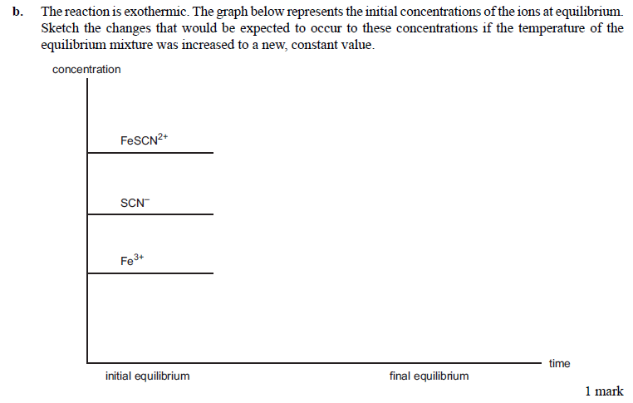

(3 marks)

**Question 9 [ 6 marks]**

In order to help prevent tooth decay, fluoride ions at a level of 0.90 mg L-1 of F- are added to Melbourne’s public water supplies. The fluoride ions are obtained by adding sodium fluoride (NaF) to the water.

a) Calculate the mass of sodium fluoride in mg that must be present in one litre of water to produce a concentration of fluoride ions of 0.90 mg L-1.

(4 marks)

b) What mass of sodium fluoride, in kilograms, must be added to a 750 megalitre reservoir (1megalitre = 106L) to produce a concentration of fluoride ions of 0.90 mg L-1?

(2 marks)

**Question 10 [ 5 marks]**

Siobhan and Meg were investigating the acidic properties of the acids of sulfur and selenium

Explain how they could experimentally determine whether selenic acid H2SeO4 was a stronger or weaker acid than sulfuric acid, H2SO4. In your answer indicate the equipment they would need and the variables they would need to control.

**Question 11 [10 marks]**

Refer to the pH data below and your knowledge of chemistry to answer the questions that follow.

|  |  |
| --- | --- |
| **sample** | **pH** |
| 0.1M acetic acid CH3COOH | 2.92 |
| 0.1M hydrocyanic acid HCN | 5.0 |
| 0.1M carbonic acid H2CO3 | 3.80 |
| Fresh egg | 8.0 |
| Pepsi Cola | ? |
| 0.1M lithium hydroxide | 13.0 |

1. Based on the pH values above what is the concentration of OH- in a typical fresh egg?

(2 marks)

1. A hydrogen ion concentration of 0.0035M is common for Pepsi Cola. What is the pH of a typical sample of Pepsi Cola?

(2 marks)

1. Which is the stronger acid – HCN or CH3COOH? Explain your answer with reference to the pH values above.

(3 marks)

1. Based on the pH data above is the statement below true or false? Explain your answer.

***CH3COO- is a stronger base than CN-***

(3 marks)

**Question 12 [4 marks]**

The titration curve shown below was obtained by titrating 20.0mL of a 0.100M solution of trimethylamine, (CH3)3N , with a dilute hydrochloric acid solution.

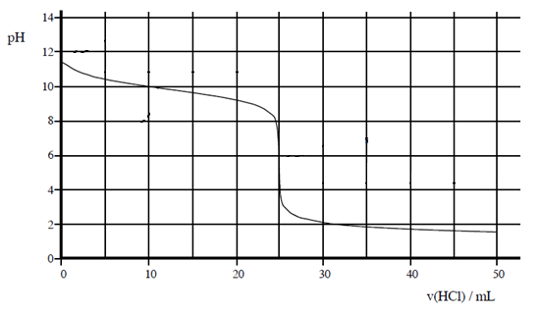

1. Is (CH3)3N a strong base or a weak base? Explain your answer.

(2 marks)

1. What indicator would you choose for this titration? Explain your answer.

(2 marks)

**SECTION THREE—EXTENDED RESPONSE [72 marks]**

Section Three has **SIX (6)** questions. Attempt **ALL** questions in the spaces provided below.

In descriptive responses, marks are awarded for relevant chemical content, including equations, diagrams and illustrative examples of the chemistry you are describing.

Calculations are to be set out in detail. Marks will be awarded for correct equations and clear setting out, even if you cannot complete the calculation. Express numerical answers to three (3) significant figures and provide units where appropriate.

Suggested working time: 70 minutes

__________________________________________________________________________

**Question 1 [13 marks]**

The equations that represent the reactions that occur in the manufacture of nitric acid from ammonia are summarised below.

**Reaction 1** 4NH3(g) + 5O2(g) ↔ 4NO(g) + 6H2O(g) ∆H = -ve

**Reaction 2** 2NO(g) + O2(g) → 2NO2(g)

**Reaction 3** 3NO2(g) + H2O(l) → 2HNO3(aq) + NO(g)

In this process reaction 1 is 91% efficient and the next two reactions are 100% efficient.

1. Calculate
2. the mass of HNO3 produced when 5 x 103 kg of NH3 is reacted.

(4 marks)

1. The volume of ammonia at STP required to produce 1000L of 12 molL-1 HNO3

(4 marks)

b) Draw a labelled energy profile diagram for reaction 1 including the transition state and heat of reaction

(4 marks)

c) Write the equilibrium constant expression for reaction 1

(1 mark)

**Question 2 [13 marks]**

A soluble fertiliser contains phosphorus in the form of phosphate ions (PO43-). To determine the PO43- content by gravimetric analysis, 5.97 g of the fertiliser powder was completely dissolved in water to make a volume of 250.0 mL. A 20.00 mL volume of this solution was pipetted into a conical flask and the PO43- ions in the solution were precipitated as MgNH4PO4. The precipitate was filtered, washed with water and then converted by heating into Mg2P2O7. The mass of Mg2P2O7 was 0.0352g.

a) Calculate the amount, in mole, of Mg2P2O7.

(2 marks)

b) Calculate the amount, in mole, of phosphorus in the 20.00 mL volume of solution.

(1 mark)

c) Calculate the amount, in mole, of phosphorus in 5.97 g of fertiliser.

(1 mark)

d) Calculate the percentage of phosphate ions (PO43-) by mass in the fertiliser.

(3 marks)

e) i) Several actions which could occur during this analytical procedure are listed below (A-D). For each action, indicate the likely effect on the calculated percentage of phosphate ions in the fertiliser by placing a tick in the appropriate box.

|  |  |  |  |
| --- | --- | --- | --- |
| **Action** | **Calculated result would be too low** | **No effect on calculated result** | **Calculated result would be too high** |
| a) The MgNH4PO4 precipitate was not washed with water |  |  |  |
| b) The conical flask has been previously washed with water but not dried |  |  |  |
| c) A 25.00 mL pipette was unknowingly used instead of a 20.00 mL pipette |  |  |  |
| d) The mass of fertiliser was recorded incorrectly. The recorded mass was 0.2 g higher than the actual mass |  |  |  |

(4 marks)

ii) In the case of action b) above, explain your reasoning for the answer that you have given.

(2 marks)

**Question 3 [17 marks]**

The main source of the element magnesium in Australia is the ore magnesite, in which magnesium is present as magnesium carbonate (MgCO3).

a) Calculate the percentage by mass of magnesium in magnesium carbonate.

(2 marks)

b) Magnesium carbonate reacts with aqueous hydrochloric acid according to the reaction

MgCO3(s) + 2HCl(aq) → MgCl2(aq) + H2O(l) + CO2(g)

A series of laboratory experiments was set up to study the rate of this reaction under some different conditions. The initial reaction rate was determined by measuring the rate of evolution of CO2 in a gas syringe as shown in the following diagram.

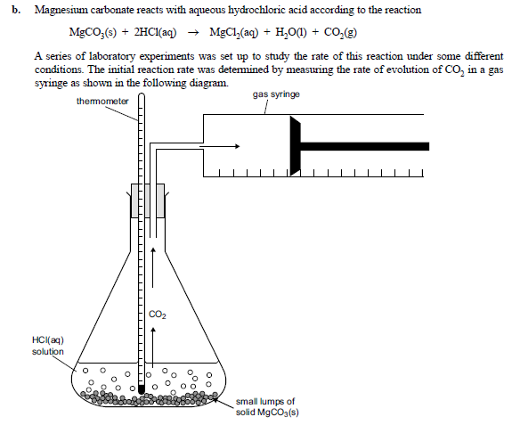

Four experiments were carried out as follows. **In each case, the amount of HCl present was in excess.**

|  |  |  |  |  |  |
| --- | --- | --- | --- | --- | --- |
| Experiment | [HCl] (M) | Mass of MgCO3(s) | Initial temp in °C | Final temp in oC | Initial rate of CO2 evolution in mL min-1 |
| 1 | 0.10 | 1.0 | 20 | 25 | 5 |
| 2 | 0.10 | 1.0 | 30 | 35 | 50 |
| 3 | 0.10 | 2.0 | 20 | 30 | 10 |
| 4 | 0.20 | 1.0 | 20 | 25 | 20 |

(i) Is the reaction exothermic or endothermic? Explain how you can tell from these results.

________________________________________________________________

________________________________________________________________

________________________________________________________________

(2 marks)

(ii) Considering experiments 1 and 2, explain why the increase in the initial temperature has raised the reaction rate.

________________________________________________________________

________________________________________________________________

(2 marks)

(iii) Considering experiments 1 and 3, explain why the greater mass of magnesium carbonate would have increased the reaction rate.

________________________________________________________________

________________________________________________________________

(2 marks)

(iv) Considering experiments 1 and 4, explain why the higher concentration of HCl would have increased the reaction rate.

________________________________________________________________

________________________________________________________________

(2 marks)

(v) Results from experiment 1 are plotted on the sketch graph below. On the same axes, sketch the results from experiment 3.

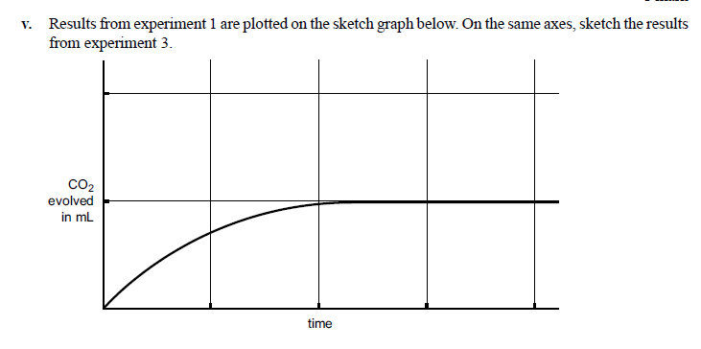

(2 marks)

(vi) Name three variables that would need to be controlled in experiment 1

__________________________________________________________________

__________________________________________________________________

__________________________________________________________________

(3 marks)

(vii) Identify two sources of error in experiment 1

__________________________________________________________________

__________________________________________________________________

(2 marks)

**Question 4 [9 marks]**

A liquid compound used in the synthesis of some flavours was analysed and found to be composed of only carbon, hydrogen and oxygen. When a 4.562g sample of the compound was burnt in air 9.115g of carbon dioxide and 3.731g of water were produced.

When a 2.66 g sample of the substance was heated and turned into a gas it had a volume of 1.00L at a pressure of 106.5kPa and a temperature of 150.0oC.

Determine

1. the empirical formula of the compound

(5 marks)

b) the molecular formula of the compound.

(4 marks)

**Question 5 [9 marks]**

Using a chemical test distinguish between the following pairs of substances. Describe the test and what you observe when each substance is tested.

|  |  |  |
| --- | --- | --- |
| **Substances** | **Chemical test** | **Observations** |
| Solid lithium carbonate  and  solid ammonium acetate |  | For lithium carbonate |
| For ammonium acetate |
| Solid magnesium sulfate  and  solid magnesium chloride |  | For magnesium sulfate |
| For magnesium chloride |
| Silver  and  magnesium |  | For silver |
| For magnesium |

**Question 6 [12 marks]**

If 20.0g of copper II nitrate and 20.0mL of 2.00M sodium hydroxide are combined they react according to the following equation. Assume the final volume of the mixture is 20.0mL

Cu(NO3)2(s) + 2NaOH(aq) → Cu(OH)2(s) + 2NaNO3(aq)

1. What will be the concentration of nitrate ions in the resulting solution?

(3 marks)

1. What mass of solid copper II hydroxide is formed?

(5 marks)

1. What will be the concentration of copper ions in the resulting solution in gL-1?

(3 marks)



**Examination**

##### Question/Answer Booklet

Please place your student identification label in this box

CHEMISTRY

**STAGE 3AB**

**Semester 1 examination**

### Time allowed for this paper

Reading time before commencing work: Ten minutes

Working time for paper: Three hours

### Material required/recommended for this paper

# To be provided by the supervisor

Question/answer booklet

Separate multiple-choice answer sheet

Data sheet

# To be provided by the candidate

Standard items: Pens, pencils, eraser, correction fluid, ruler, highlighter

Special items: Scientific calculator

# *Important note to candidates*

No other items may be taken into the examination room. It is **your** responsibility to ensure that you do not have any unauthorised notes or other items of a non-personal nature in the examination room. If you have any unauthorised material with you, hand it to the supervisor **before** reading any further.

|  |  |  |
| --- | --- | --- |
| **Section** | **Out Of** |  |
| Multiple Choice | /50 |
| Short Answers | /67 |
| Extended response | /73 |
| **Total** | /190 | **%** |

Multiple choice answers

* 1. b
  2. b
  3. c
  4. a
  5. b
  6. c
  7. a
  8. a
  9. b
  10. c
  11. a
  12. c
  13. d
  14. d
  15. c
  16. d
  17. b
  18. d
  19. c
  20. c
  21. c
  22. d
  23. d
  24. c
  25. a

**SECTION TWO—SHORT RESPONSE [69 marks]**

Section Two contains **twelve (12)** questions. Attempt **ALL** questions in the spaces provided.

In this section, unless asked to write molecular equations, chemical equations should refer only to those species consumed in the reaction and the new species produced. These species may be **ions** [for example(*aq*), **molecules** [for example NH3(*g*),NH3(aq),CH3COOH*()*, CH3COOH*(aq)* ] or **solids** [for example BaSO4*(s)* ,Cu*(s)*, Na2SO4(s)].

Suggested working time: 60 minutes

________________________________________________________________________

**Question 1 [12 marks]**

Write equations for any reactions that occur in the following procedures. If no reaction occurs write ‘no reaction’.

In each case describe in full what you would observe, including any

* Colours
* Odours
* Precipitates (give the colour)
* Gases evolved (give the colour or describe as colourless)

If no change is observed, you should state this.

a) Dilute hydrochloric acid is added to copper metal

**Equation** No reaction

Observation nvr

(3 marks)

b) Solid potassium carbonate is added to dilute acetic acid.

**Equation** K2CO3(s) + 2CH3COOH(aq) → CO2(g) + H2O(l) + 2K+(aq) + 2CH3COO-(aq)

Observation A white solid is added to a colourless solution and a colourless odourless gas is formed in a colourless solution.

(3 marks)

**Question 2 [ 4 marks]**

Write the electronic configuration for the following species

a) an argon atom 2, 8, 8

b) a sodium ion 2, 8

c) a magnesium atom 2, 8, 2

d) a nitride ion 2, 8

**Question 3 [4 marks]**

a) Classify the following salts as forming acidic, basic or neutral solutions.

|  |  |
| --- | --- |
| **salt** | **classification** |
| Ammonium chloride | Acidic |
| Sodium acetate | Basic |
| Sodium chloride | Neutral |
| Na2CO3 | Basic |

(2 marks)

b) From the table choose a salt that forms an acidic or basic solution and justify its classification. Include an equation to illustrate your answer.

NH4Cl NH4+ is acidic because it hydrolyses in water to produce hydronium ions

NH4+ + H2O ⇌ NH3 + H3O+ (1 mk)

Cl- is neutral because it does not undergo hydrolysis (1 mk)

(2 marks)

**Question 4 [5 marks]**

1. Describe and explain the trend in atomic radii of the atoms Na, Mg, Al and Si.

* The atomic radius decreases across the period from Na to Si (1 mk)
* This is because greater positive charge in nucleus and there are more electrostatic forces of attraction between positively charged nucleus and negatively charged valence electrons (1 mk)

(2 marks)

b) Describe the trend in the atomic radii of the atoms F, Cl and Br. Explain how this affects their ease of conversion to the ions F-, Cl- and Br -.

* Increase in atomic radius as additional electron shell is added as you move down group (1 mk)
* This means valence electrons are held less tightly as they are further away from positively charged nucleus (1 mk) (or less attraction)
* Hence F forms F- more easily (1 mk)

(3 marks)

**Question 5 [ 3 marks]**

Many foods that contain citric acid also have sodium citrate added as an ‘acidity regulator’. This means that the mixture acts as a buffer solution.

**equation 1** HA ⇌ H+ + A-

Use **equation 1** to explain how a buffer solution containing HA and A- works.

* A buffer solution resists a change in pH (1 mk)
* If an acid is added the A- will react with hydrogen ions to form HA (1 mk)
* If a base the OH- will react with H+ and favour forward rxn(1 mk)

**Question 6 [6 marks]**

For each species listed in the table below, draw the structural formula, representing all valence electron shell pairs as : or – and state or draw the shape of the molecule or ion.

|  |  |  |
| --- | --- | --- |
| **Molecule or ion** | **Structural formula**  **(showing all valence shell electrons)** | **Shape**  **(sketch or name)** |
| Carbon disulfide  CS2 |  | linear |
| NCF |  | linear |
| hydrogencarbonate  HCO3- |  | Trigonal planar |

**Question 7 [5 marks]**

To live, the human body needs a regular supply of oxygen, which is distributed throughout the body by the red pigment, haemoglobin (Hb). Hb is carried around the body by the red blood cells in the blood. A simple equation representing oxygen reacting with haemoglobin is shown below.

HbH+(aq) + O2(aq) ↔ HbO2(aq) + H+(aq)

a) With reference to the equation above explain, in terms of equilibrium principles, how a low oxygen concentration can lead to the cells in a human body being deprived of oxygen.

A low concentration of O2 slows forward reaction (1 mk) which decreases [HbO2] (1 mk) The oxygen is delivered to cells by HbO2 and so if [HbO2] is low then the cells will have less O2 (1 mk)

(3 marks)

1. At high altitudes, the pressure of atmospheric oxygen is significantly less than it is at sea level. People who live most of their lives on very high mountains normally have a number of special adaptations to living at high altitudes. One such adaptation is the possession of a significantly higher red blood count (that is, a larger number of red blood cells in the blood) compared with people living at sea level. Explain how a high blood count is a useful adaptation to high altitude living.

At high altitude [O2] is lower and hence [HbO2] is lower within each red blood cell. If the number of red blood cells is increased then the amount of O2 delivered to cells can be increased (even though the concentration of HbO2 is lower). (1 mk) Increased [HbH+] favours forward reaction. More HbO2 so more O2 available. (1 mk)

(2 marks)

**Question 8 [ 11 marks]**

In solution, pale yellow-coloured Fe3+(aq) and colourless SCN-(aq) form an equilibrium with FeSCN2+(aq). FeSCN2+(aq) is red in colour.

Fe3+(aq) + SCN-(aq) ⇌ FeSCN2+(aq); ∆H negative

red colour

a) A student investigates this reaction using separate samples of an equilibrium mixure in which significant quantities of Fe3+, SCN- and FeSCN2+ are present. In each case changes are made as indicated in the table below.

Complete the table by placing ticks in the appropriate boxes to indicate the effect of each change on

i the intensity of the red colour of the solution; and

ii the concentration of Fe3+(aq)

once the new equilibrium has been established.

|  |  |  |  |  |
| --- | --- | --- | --- | --- |
| Change to the equilibrium | i. Colour at new equilibrium compared with initial equilibrium | | ii. [Fe3+] at new equilibrium compared with initial equilibrium | |
|  | Less red | More red | Decreased | Increased |
| **Sample 1:** 1 drop of a concentrated solution of Ag+(aq) is added, which forms a AgSCN precipitate | 🗸 |  |  | 🗸 |
| **Sample 2:** 1 drop of a concentrated solution of Fe3+(aq) is added |  | 🗸 |  | 🗸 |
| **Sample 3:** 1 drop of a concentrated solution of HPO42-(aq) is added, which forms colourless FeHPO4+(aq) | 🗸 |  | 🗸 |  |
| **Sample 4:** Addition of a large volume of water | 🗸 |  | 🗸 |  |

(8 marks)

b) The reaction is exothermic. The graph below represents the initial concentrations of the ions at equilibrium. Sketch the changes that would be expected to occur to these concentrations if the temperature of the equilibrium mixture was increased to a new, constant value.

Favour reverse reaction because it is endo

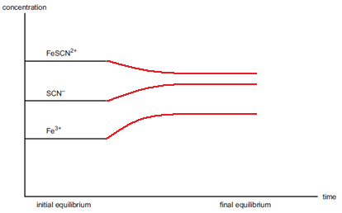

(3 marks)

**Question 9 [ 6 marks]**

In order to help prevent tooth decay fluoride ions at a level of 0.90 mg L-1 of F- are added to Melbourne’s public water supplies. The fluoride ions are obtained by adding sodium fluoride (NaF) to the water.

a) Calculate the mass of sodium fluoride in mg that must be present in one litre of water to produce a concentration of fluoride ions of 0.90 mg L-1.

nF = = 4.74 x 10-5 mol (1 mk)



nNaF = nF = 4.74 x 10-5 mol (1 mk)

mass NaF = 4.74 x 10-5 x (22.99 + 19) = 1.99 x 10-3g (1 mk)

= 1.99mg (1 mk)

(3 marks)

b) What mass of sodium fluoride, in kilograms, must be added to a 750 megalitre reservoir (1megalitre = 106L) to produce a concentration of fluoride ions of 0.90 mg L-1?

750 000 000 = ? x

x = 149 2500 g (1 mk)

= 1490 kg (1 mk)

(2 marks)

**Question 10 [ 5 marks]**

Siobhan and Meg were investigating the acidic properties of the acids of sulfur and selenium

1. Explain how they could experimentally determine whether selenic acid H2SeO4 was a stronger or weaker acid than sulfuric acid, H2SO4. In your answer indicate the equipment they would need and the variables they would need to control.

* Take sample solution of each acid at the same concentration (1 mk)
* Test electrical conductivity (1 mk) or pH
* The better conductor is the stronger acid (1 mk) or lower pH
* Use circuit with power supply, ammeter, electrodes (1 mk)
* Control concentration, temp, amount of current (1 mk)

(5 marks)

**Question 11 [10 marks]**

Refer to the pH data below and your knowledge of chemistry to answer the questions that follow.

|  |  |
| --- | --- |
| **sample** | **pH** |
| 0.1M acetic acid CH3COOH | 2.92 |
| 0.1M hydrocyanic acid HCN | 5.0 |
| 0.1M carbonic acid H2CO3 | 3.80 |
| Fresh egg | 8.0 |
| Pepsi Cola | ? |
| 0.1M lithium hydroxide | 13.0 |

1. Based on the pH values above what is the concentration of OH- in a typical fresh egg?

[H+] = 1 x 10-8 (1 mk)

[OH-] = = 1 x 10-6 M (1 mk)



(2 marks)

1. A hydrogen ion concentration of 0.0035M is common for Pepsi Cola. What is the pH of a typical sample of Pepsi Cola?

pH = -log [H+] (1 mk)

pH = -log (0.0035) = 2.46 (1 mk)

(2 marks)

1. Which is the stronger acid – HCN or CH3COOH? Explain your answer with reference to the pH values above.

* The one that has ionised to a greater extent (1 mk)
* Hence has greater [H+] (1 mk)
* Hence lower pH i.e. acetic acid (1 mk)

(3 marks)

1. Based on the pH data above is the statement below true or false? Explain your answer.

***CH3COO- is a stronger base than CN-***

* In CH3COOH the forward reaction occurs to a greater extent than the forward reaction for ionisation of HCN (1 mk)
* Hence CH3COO- + H+ → CH3COOH is occurring to lesser extent (1 mk) than

CN- + H+ → HCN, CN- is a stronger base as it reacts more readily with H+.

* Statement is false (1 mk)

(3 marks)

**Question 12 [4 marks]**

The titration curve shown below was obtained by titrating 20.0mL of a 0.100M solution of trimethylamine, (CH3)3N , with a dilute hydrochloric acid solution.



1. Is (CH3)3N a strong base or a weak base? Explain your answer

A weak base (1 mk)

The equivalence point is acidic i.e. over a range below pH = 7 (1 mk)

(2 marks)

1. What indicator would you choose for this titration? Explain your answer.

Methyl orange (1 mk)

Because methyl orange changes colour (has an endpoint) between 3-4 and this falls within the pH change of the equivalence point.

(2 marks)

**SECTION THREE—EXTENDED RESPONSE [72 marks]**

Section Three has **SIX (6)** questions. Attempt **ALL** questions in the spaces provided below.

In descriptive responses, marks are awarded for relevant chemical content, including equations, diagrams and illustrative examples of the chemistry you are describing.

Calculations are to be set out in detail. Marks will be awarded for correct equations and clear setting out, even if you cannot complete the calculation. Express numerical answers to three (3) significant figures and provide units where appropriate.

Suggested working time: 70 minutes

__________________________________________________________________________

**Question 1 [13 marks]**

The equations that represent the reactions that occur in the manufacture of nitric acid from ammonia are summarised below.

**Reaction 1** 4NH3(g) + 5O2(g) ↔ 4NO(g) + 6H2O(g) ∆H = -ve

**Reaction 2** 2NO(g) + O2(g) → 2NO2(g)

**Reaction 3** 3NO2(g) + H2O(l) → 2HNO3(aq) + NO(g)

In this process reaction 1 is 91% efficient and the next two reactions are 100% efficient.

1. Calculate
2. the mass of HNO3 produced when 5 x 103 kg of NH3 is reacted.

nNH3 = = = 29 3530.6 mol (1 mk)



nNO = x nNH3 = 29 3530.6 mol (1 mk) if 100% efficient



nNO if 91% efficient = 29 3503.6 x = 267 112.8 mol (1 mk)



nHNO3 = x nNO2 = x 267 112.8 mol = 178 075.2 mol (1 mk)



mass HNO3 = 178 075.2 x (1.008 + 14.01 + 3 x 16) = 178 075.2 x 63.018 (1 mk)

= 1.12 x 107g

(4 marks)

1. The volume of ammonia at STP required to produce 1000L of 12 molL-1 HNO3

nHNO3 = cv = (12)(1000) = 12 000 mol (1mk)

nNH3 = x nHNO3 = x 12 000 = 18 000 (1 mk)



assume 100%

extra needed because rxn 1 only 91% efficient

nNH3 = 18 000 x = 19 780 mol (1 mk)



V = 19 780 x 22.41 = 4.43 x 105 L (1 mk)

(4 marks)

b) Draw a labelled energy profile diagram for reaction 1 including the transition state and heat of reaction

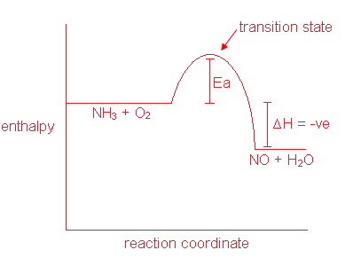

(4 marks)

c) Write the equilibrium constant expression for reaction 1

K =



(1 mark)

**Question 2 [13 marks]**

A soluble fertiliser contains phosphorus in the form of phosphate ions (PO43-). To determine the PO43- content by gravimetric analysis, 5.97 g of the fertiliser powder was completely dissolved in water to make a volume of 250.0 mL. A 20.00 mL volume of this solution was pipette into a conical flask and the PO43- ions in the solution were precipitated as MgNH4PO4. The precipitate was filtered, washed with water and then converted by heating into Mg2P2O7. The mass of Mg2P2O7 was 0.0352g.

a) Calculate the amount, in mole, of Mg2P2O7.

nMg2P2O7 = = = 1.58 x 10-4 mol



(2 marks)

b) Calculate the amount, in mole, of phosphorus in the 20.00 mL volume of solution.

nP = x nMg2P2O7 = x 1.58 x 10-4 mol = 3.16 x 10-4



(in 20mL)

(1 mark)

c) Calculate the amount, in mole, of phosphorus in 5.97 g of fertiliser.

nP = 3.16 x 10-4 x = 3.95 x 10-3 mol (1 mk)



(in 250mL)

(1 mark)

d) Calculate the percentage of phosphate ions (PO43-) by mass in the fertiliser.

nPO43- = nP = 3.95 x 10-3 mol (1 mk)

mass PO43- = 3.95 x 10-3 x (30.97 + 4 x 16)

= 3.95 x 10-3 x 94.97

= 0.375 g (1 mk)

% PO43- = = = 100



= 6.28% (1 mk)

(3 marks)

e) i) Several actions which could occur during this analytical procedure are listed below (A-D). For each action, indicate the likely effect on the calculated percentage of phosphate ions in the fertiliser by placing a tick in the appropriate box.

|  |  |  |  |
| --- | --- | --- | --- |
| **Action** | **Calculated result would be too low** | **No effect on calculated result** | **Calculated result would be too high** |
| a) The MgNH4PO4 precipitate was not washed with water |  |  | 🗸 |
| b) The conical flask has been previously washed with water but not dried |  | 🗸 |  |
| c) A 25.00 mL pipette was unknowingly used instead of a 20.00 mL pipette |  |  | 🗸 |
| d) The mass of fertiliser was recorded incorrectly. The recorded mass was 0.2 g higher than the actual mass | 🗸 |  |  |

(4 marks)

ii) In the case of action b) above, explain your reasoning for the answer that you have given.

More water in the conical flask will not change the number of moles of the reacting species and hence will not alter mass of precipitate formed.

(2 marks)

**Question 3 [17 marks]**

The main source of the element magnesium in Australia is the ore magnesite, in which magnesium is present as magnesium carbonate (MgCO3).

a) Calculate the percentage by mass of magnesium in magnesium carbonate.

% Mg = + 12.01 + 3 x 16 x 100 = x 100 = 28.8%



(2 marks)

b) Magnesium carbonate reacts with aqueous hydrochloric acid according to the reaction

MgCO3(s) + 2HCl(aq) → MgCl2(aq) + H2O(l) + CO2(g)

A series of laboratory experiments was set up to study the rate of this reaction under some different conditions. The initial reaction rate was determined by measuring the rate of evolution of CO2 in a gas syringe as shown in the following diagram.



Four experiments were carried out as follows. **In each case, the amount of HCl present was in excess.**

|  |  |  |  |  |  |
| --- | --- | --- | --- | --- | --- |
| Experiment | [HCl] (M) | Mass of MgCO3(g) | Initial temp in °C | Final temp in oC | Initial rate of CO2 evolution in mL min-1 |
| 1 | 0.10 | 1.0 | 20 | 25 | 5 |
| 2 | 0.10 | 1.0 | 30 | 35 | 50 |
| 3 | 0.10 | 2.0 | 20 | 30 | 10 |
| 4 | 0.20 | 1.0 | 20 | 25 | 20 |

(i) Is the reaction exothermic or endothermic? Explain how you can tell from these results.

* Exothermic (1 mk)
* The temperature increases during the reaction (1 mk)

(2 marks)

(ii) Considering experiment 1 and 2, explain why the increase in the initial temperature has raised the reaction rate.

* Higher temp means greater KE of reacting particles (1 mk)
* Collisions will be more frequent and collisions will be more likely to have the necessary activation energy (1 mk)

(2 marks)

(iii) Considering experiments 1 and 3, explain why the greater mass of magnesium carbonate would have increased the reaction rate.

* Larger SA
* More collisions

(2 marks)

(iv) Considering experiments 1 and 4, explain why the higher concentration of HCl would have increased the reaction rate.

* Greater concentration increases frequency of collisions between reacting particles (1 mk)
* This increased frequency of successful collisions (1 mk)

(2 marks)

(v) Results from experiment 1 are plotted on the sketch graph below. On the same axes, sketch the results from experiment 3.

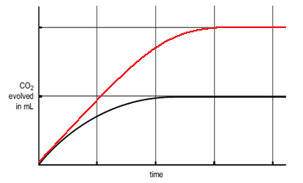

(2 marks)

(vi) Name three variables that would need to be controlled in experiment 1

* Agitation/stirring
* Size of conical flask
* Particle size of MgCO3
* Purity of solid
* Syringe used

(variables such as mass, conc of acid assumed to really be dep or indep variables in the context of this question)

(3 marks)

(vii) Identify two sources of error in experiment 1

* Some CO2 produced dissolved in solution
* Error in reading the volume on syringe
* Heat generated by reaction caused air in flask to expand

(2 marks)

**Question 4 [9 marks]**

A liquid compound used in the synthesis of some flavours was analysed and found to be composed of only carbon, hydrogen and oxygen. When a 4.562g sample of the compound was burnt in air 9.115g of carbon dioxide and 3.731g of water were produced.

When a 2.66 g sample of the substance was heated and turned into a gas it had a volume of 1.00L at a pressure of 106.5kPa and a temperature of 150.0oC.

Determine

a) the empirical formula of the compound

|  |  |  |  |
| --- | --- | --- | --- |
|  | C | H | O |
| Mass | x 9.115  2.487 g (1 mk) | x 3.731  0.4175 g (1 mk) | 4.562-(2.487+0.4175) =  1.657 g (1 mk) |
| Moles | 0.207 | 0.414 | 0.104 ( mk) |
| Ratio | 2 | 4 | 1 (1 mk) |

(5 marks)

b) the molecular formula of the compound.

EF mass is (2 x 12.01) + (4 x 1.008) + 16 = 44.052 (1 mk)

PV = nRT

(106.5) (1) = n(8.315)(423)

n = 0.03028 mol (1 mk)

n = 0.03028 =



⇒ molar mass = 88 (1 mk)

MF is C4H8O2  (1 mk)

(4 marks)

**Question 5 [9 marks]**

Using a chemical test distinguish between the following pairs of substances. Describe the test and what you observe when each substance is tested.

|  |  |  |
| --- | --- | --- |
| **Substances** | **Chemical test** | **Observations** |
| Solid lithium carbonate  and  solid ammonium acetate  note that in the marking of this question all lithium compounds are assumed to be soluble (because group 1) | Add HCl(aq) to both solids | For lithium carbonate  The solid will fizz with a colourless odourless gas being formed |
| For ammonium acetate  The solid will dissolve |
| Solid magnesium sulfate  and  solid magnesium chloride  these solids had to be dissolved in water and a specific barium compound had to be specified | Dissolve both solids in water then add Ba(NO3)2(aq) | For magnesium sulfate  The solid will dissolve in the water and then form a white precipitate when Ba(NO3)2(aq) is added |
| For magnesium chloride  The solid will dissolve in the water and there will be no further change when Ba(NO3)2(aq) is added |
| Silver  and  magnesium | React both solids with HCl(aq) | For silver  No visible change |
| For magnesium  A colourless, odourless gas will be formed |

**Question 6 [11 marks]**

If 20g of copper II nitrate and 20mL of 2M sodium hydroxide are combined they react according to the following equation. Assume the final volume of the mixture is 20mL

Cu(NO3)2(s) + 2NaOH(aq) → Cu(OH)2(s) + 2NaNO3(aq)

a) What will be the concentration of nitrate ions in the resulting solution?

nCu(NO3)2 = = = 0.107 mol (1 mk)



nNO3- = x nCu(NO3)2 = x 0.107 = 0.213 (1 mk)



C = = = 10.7 M (1 mk)



(3 marks)

b) What mass of solid copper II hydroxide is formed?

(note that if correct answer but LR not used then mark of 2/5 awarded)

nNaOH = cv = (2)(0.02) = 0.04 mol (1 mk)

need = = given = =



∴ LR is NaOH (2 mk)

nCu(OH)2 = x nNaOH = x 0.04 = 0.02 mol (1 mk)



mass Cu(OH)2 = 0.02 x (63.55 + 2 x 16 + 2 x 1.008)

= 0.02 x 97.566 = 1.95 g (1 mk)

(5 marks)

1. What will be the concentration of copper ions in the resulting solution in gL-1?

mole Cu(NO3)2 that does react = x NaOH = x 0.04 = 0.02 (1 mk)



mole Cu2+(aq) in final solution = 0.107 – 0.02 = 0.087 mol (1 mk)

CCu2+ = = 4.35 M (1 mk)



Conc Cu2+ = 4.35 x 63.55 = 276gL-1 (1 mark penalty if this step not completed)

(3 marks)